Idris Ratlamwala

C31 - 2003145

Experiment 5: Programs on One Dimensional Arrays

**Theory :**

**One Dimensional Array** in javais always used with only one “[]”. A one-dimensional array behaves likes a list of variables. You can access the variables of an array by using an index in square brackets preceded by the name of that array. Index value should be an integer.

**Steps:**

* Declaration  of Array
* Construction of Array
* Initialization of Array

**Declaration of One-dimensional array in java**

Before using the array, we must declare it. Like normal variables, we must provide data type of array and name of an array. We also need to specify the name of an array so that we can use it later by name.

datatype[] arrayName;

Or

datatype arrayName[];

Or

datatype []arrayName;

* **datatype** can be a **primitive data type**(int, char, Double, byte etc.)or**Non-primitive data** (Objects).
* **arrayName** is the name of an array
* **[]**is called subscript.

Eg.

**int**[] number

**Construction of** **One-dimensional array in java**

For the creation of an array new keyword is used with a **data type** of array. we must specify the size of the array. The size should be an integer value or a variable that contains an integer value. How many elements you can store an array directly depends upon the size of an array.

arrayName = new DataType[size];

**Note:** When we are creating a new array the elements in the array will automatically be initialized by their default values. For e.g. : **zero** (int types), **false** (boolean), or **null** (for object types).

**Initialization of One-dimensional array in java**

To initialize the Array we have to put the values at each index of array. Hence we use single for loop to initialize array.

Eg.

for(int i=0 ;i<n ;i++) array[i]= sc.nextInt();

**A.**

**Aim :** WAP to count number of even and odd elements from an array.

**Program :**

    import java.util.Scanner;

    public class OddEven {

        public static void main(String[] args) {

            Scanner sc = new Scanner(System.in);

            System.out.print("Enter the number of elements in the array :");

            int n= sc.nextInt();

            int[] a = new int[n];

            System.out.println("Enter the elements:");

            for(int i=0;i<n;i++) a[i]= sc.nextInt();

            int even=0,odd=0;

            for(int i=0;i<n;i++){ //this could be done in above loop, but then there is no meaning of Aim.

                if(a[i]%2==0) even++;

                else odd++ ;

            }

            System.out.println("Number of odd elements:"+odd+"\nNumber of even elements:"+even);

        }

    }

**Output :**

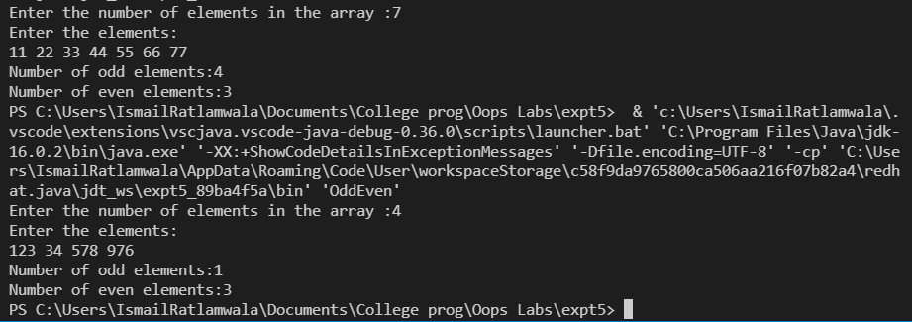

**B.**

**Aim :** WAP to count total marks and highest marks obtained by a student.

**Program :**

    import java.util.Scanner;

    public class marks {

        public static void main(String[] args) {

            Scanner sc = new Scanner(System.in);

            int[] a = new int[6];

            System.out.println("Enter the marks of 6 subjects(out of 100):");

            for(int i=0;i<6;i++) a[i]= sc.nextInt();

            int sum=0,highest=0;

            for(int i=0;i<6;i++){

                sum=sum+a[i];

                highest=(highest<a[i]) ? a[i]:highest;

            }

            System.out.println("Total marks scored :"+sum+"/600\nHighest marks are scored is :"+highest);

        }

    }

**Output** :

